
dgj

Ettercap is an open-source network security tool, primarily used for network protocol analysis and network security assessments. It is well-known for its capabilities in conducting man-in-the-middle (MITM) attacks, allowing users to intercept, modify, or inject data into network communications between devices.
There are a number of uses for Ettercap, including:
Man-in-the-Middle (MITM) Attacks:
Ettercap can perform various MITM attacks, where it intercepts and potentially alters communication between two parties without them knowing. This is useful for testing the security of networks by simulating how an attacker might eavesdrop on or manipulate data.
Packet Sniffing:
It captures and analyses network traffic, enabling users to inspect the contents of packets being transmitted over the network. This is useful for diagnosing network issues or investigating suspicious activities.
ARP Spoofing/Poisoning:
This feature allows Ettercap to send fake Address Resolution Protocol (ARP) messages to a local network, linking the attacker's MAC address to the IP address of another device. This way, the attacker can receive any traffic intended for that IP address.

What you will need:
- VMware
- Kali Linux Virtual machine (with Ettercap installed)
- Windows 10 Virtual Machine
- Wireshark

Man-In-The-Middle with Ettercap

Security professionals use Ettercap to simulate attacks on networks to identify vulnerabilities and weaknesses. While Ettercap is a powerful tool for network security testing, it can also be used maliciously.
Ethical use of Ettercap involves ensuring that it is only used on networks with proper authorization, such as during penetration testing with the consent of the network owner.
Misuse of Ettercap for unauthorized monitoring, interception, or manipulation of network traffic can be illegal and unethical.

- Launching Ettercap
- Open a terminal in your Kali Linux machine.
- To launch Ettercap in graphical mode, type the following command:
- Sudo Ettercap -G (This will open the Ettercap GUI)

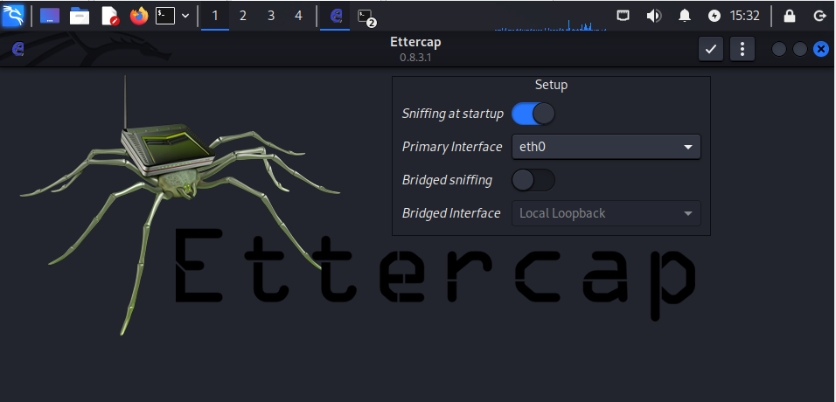
Note: You will need to ensure that your VMs are all on the same network within VMware’s network editor.

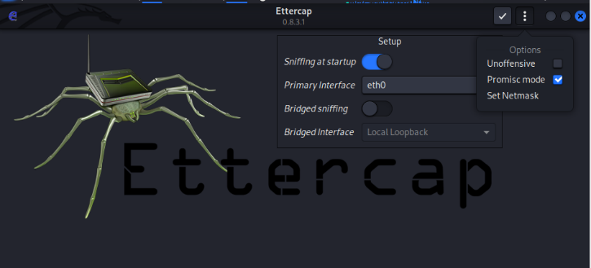
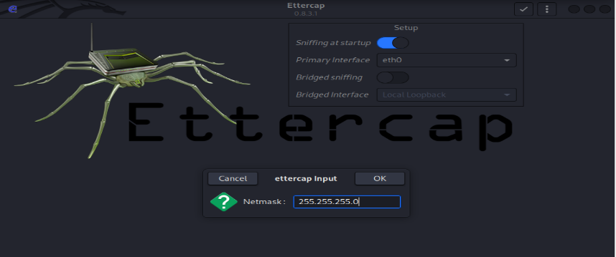
Note: Ensure that you enter the netmask of the network that your VM is currently on
2. Select the Network Interface
  - In Ettercap, ensure that the correct interface is selected
  - Open Options and select Set Netmask
3. Scan for Hosts
- To discover hosts on the network, got to Hosts -> Scan for Hosts.
- Ettercap will scan the network and list all the active devices

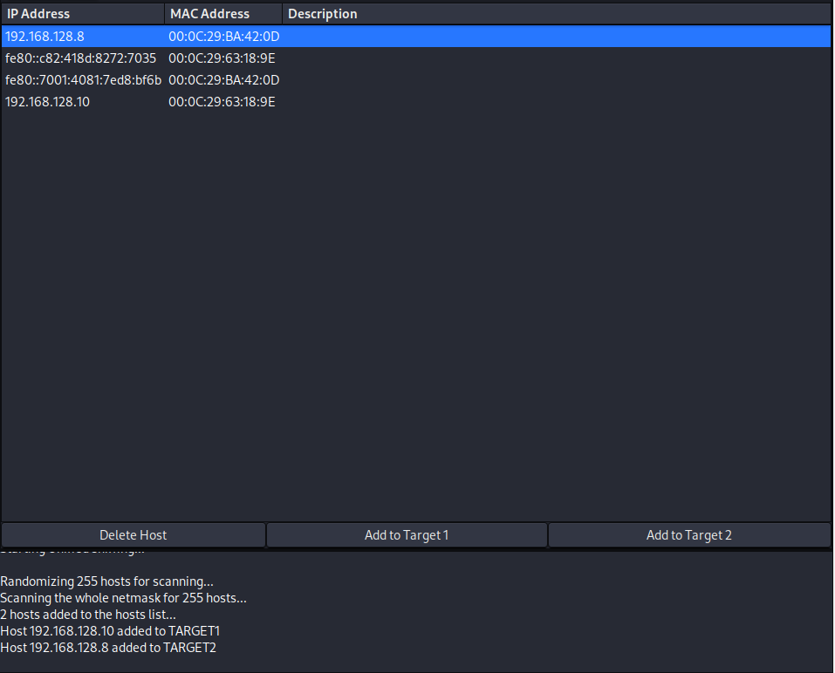
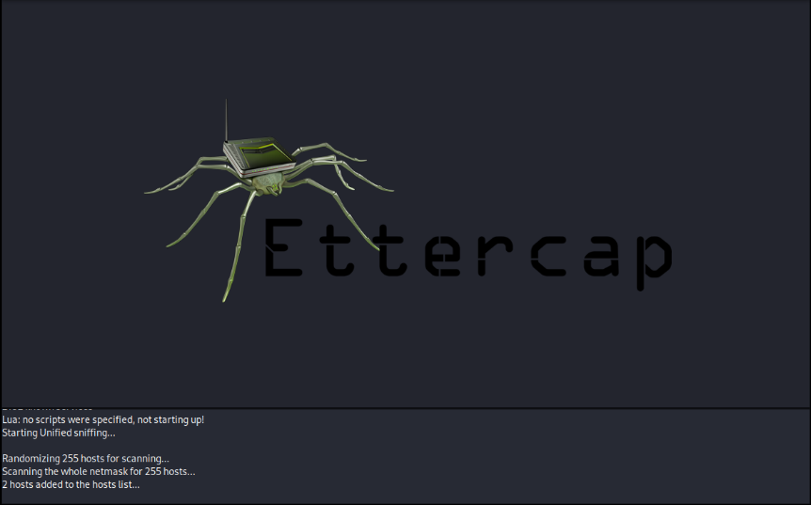
4. Add Hosts to Target list
- After the scan, go to Hosts -> Hosts List to view the detected devices.
- Identify the IP address of the victim machine
- Add the victim machine to the Target 1 list by selecting it and click Add to Target 1
- Optionally, add the router (default gateway) to target 2 for a full MITM attack.

5. Start ARP Poisoning
- Go to Mitm -> ARP Poisoning
- In the ARP poisoning window, check the box for Sniff Remote Connections
- Click OK to start the ARP poisoning attack

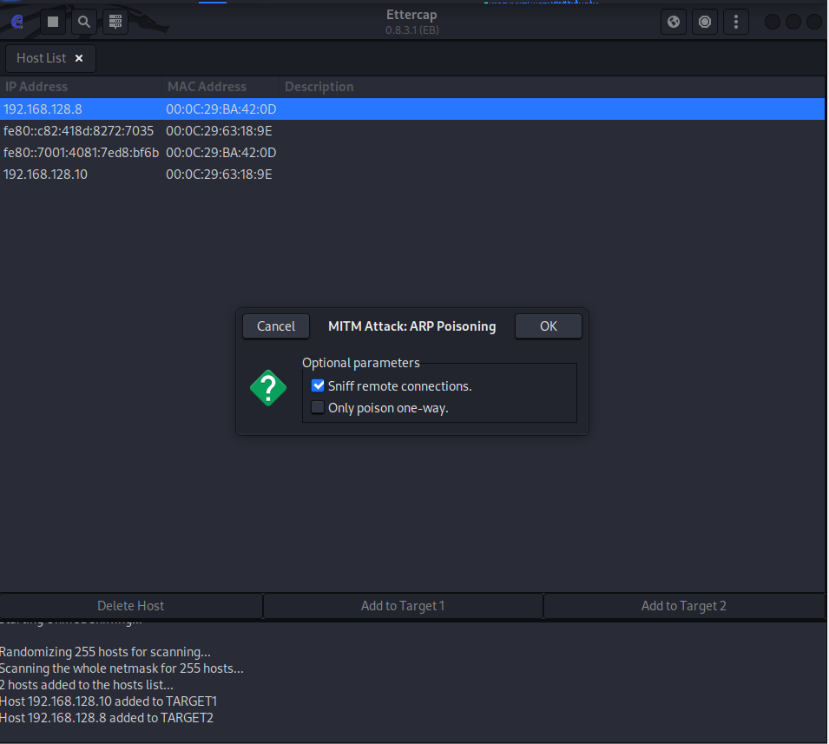

6. Capture and Analyse Traffic
- As the ARP Poisoning attack is ongoing, Ettercap will start capturing the network traffic between the victim and other devices, such as the router.
- Go to View -> Connections, to see the live connections and captured data.

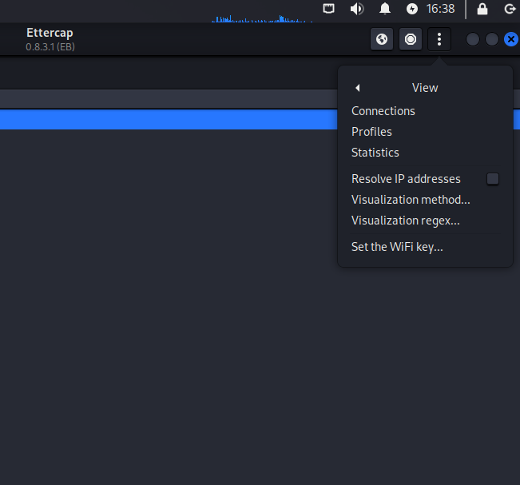

7. Viewing Captured Data
- Select a connection from the list and click View -> Show Packets, to see the captured packets.
- Examine the contents of the packets to see if any sensitive information (like usernames and passwords) is transmitted in plaintext.

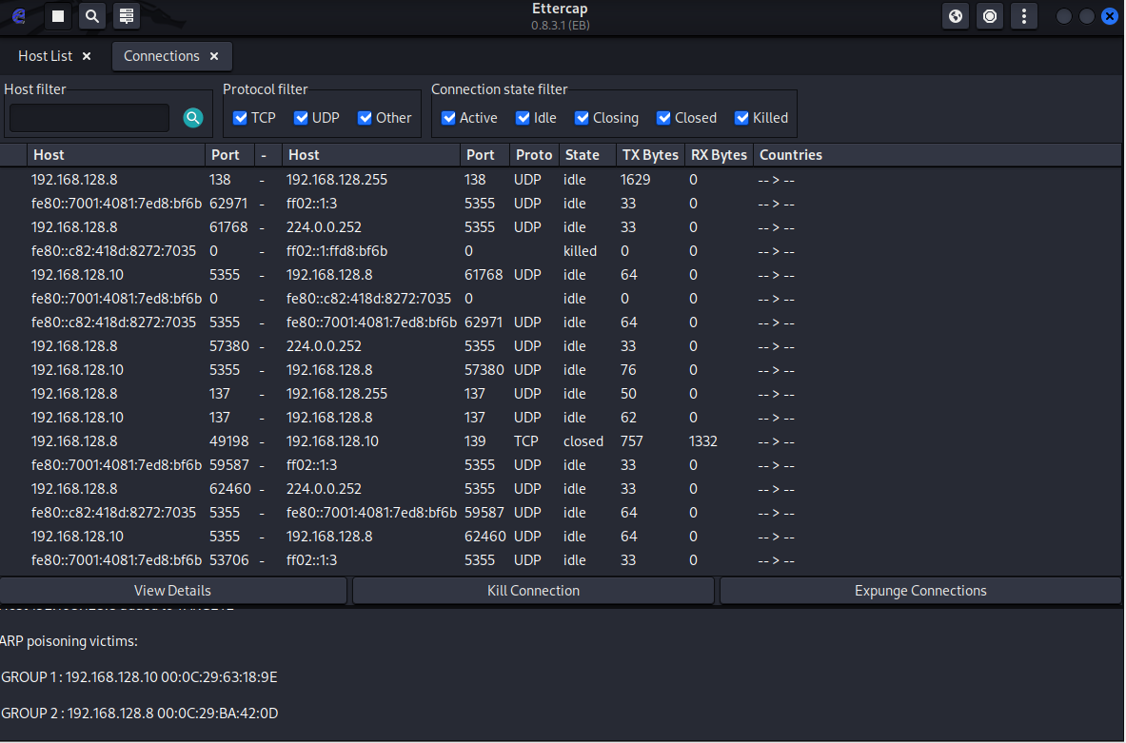

Wireshark
We can also use Wireshark to capture and view traffic. We can see that ARP poisoning is taking place due to duplicate addresses being identified as shown below.

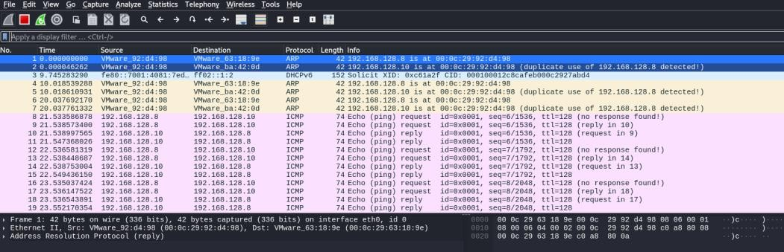

Mitigation:
While Ettercap is a valuable tool for pen testing and security education, it is equally important to understand how to defend against the attacks it demonstrates. Some common methods to reduce the risk of ARP spoofing and MITM attacks on a network are:
- Encrypted Protocols
- Encourage the use of HTTPS, SSH, and TLS-secured protocols instead of plaintext
- Even if traffic is intercepted, encryption makes it more difficult for attackers to read or manipulate sensitive data.
- Implement Static ARP Entries
- For critical systems (Servers, routers), define static ARP entries instead of relying on dynamic ARP resolution.
- This prevents attackers from injecting false ARP replies into the cache
- Static entries are however harder to maintain on larger networks.
- Deploy ARP Spoofing Detection Tools
- Use intrusion detection/prevention systems (IDS/IPS) that monitors ARP traffic for unusual behaviour (e.g duplicate IP addresses with different MAC addresses)
- These tools can alert administrators when spoofing is detected.
- Network Segmentation
- Divide the network into smaller VLANS to limit broadcast domains.
- This reduced the attackers ability to target all hosts within a large flat network.
- Enable Dynamic ARP Inspection
- On managed switches, enable Dynamic ARP Inspection, which validates ARP packets against a trusted database.
- This blocks malicious ARP re[plies from reaching their targets.
- Regular Monitoring and Logging
- Monitor for unusual network behaviour such as sudden connection drops, unexpected SSL certificate warnings, or duplicate IP/MAC conflicts
- Logging tools can help trace spoofing attempts back to their source.
- User Awareness
- Train users to recognise warning signs of MITM attacks, such as browser certificate errors or unexpected login prompts.

